Digital Logic Design Lab # 09

# Student Name: Muhammad Ahmed Baig Reg# 20i-1884

***Lab Section: B***

### LabTitle:

555 Timer and Latches

### Objectives:

* Getting familiar with 555 Timer
* Generate clock at different frequencies
* Getting familiar with characteristic tables and characteristic functions of latches
* Gaining a close insight into the functioning and properties of basic static memory circuits
* Developing skills in the composition and testing of sequential logic circuits.

### Equipment Required:

* DEV-2765E Trainer Board
* 74LS393 pre settable counter
* 7400 NAND Gate IC
* 555 Timer IC

**Background Theory:**

The elements used to store binary information in sequential circuits are called latches and flip-flops. A storage element can maintain a binary state as long as power is delivered to the circuit until directed by an input signal to switch states. The major differences among the various types of latches and flip-flops are the number of inputs they possess and the manner inputs affect the binary state. The most basic storage elements are latches, which uses feedback to lock onto and hold data, from which flip-flops are usually constructed. Although latches are most often used within flipflops, they can also be used with more complex clocking methods to implement equential circuits directly.

## LATCHES

1. Draw the circuit diagram of a NAND latch (SR) below

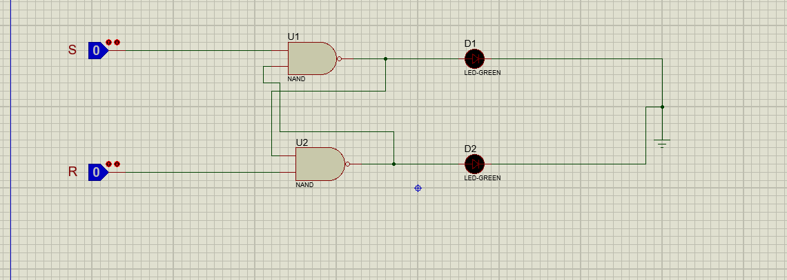

1. Construct the circuit on the breadboard and fill the following truth table according to the outputs your circuit gives.

|  |  |  |
| --- | --- | --- |
| **S** | **R** | **Next State of Q** |
| 0 | 1 | 0 |
| 1 | 1 | Hold |
| 1 | 0 | 1 |
| 0 | 0 | undefined |

1. Draw the circuit diagram of a SR latch with a control input below. (Modify the circuit you implemented in part ‘a’)

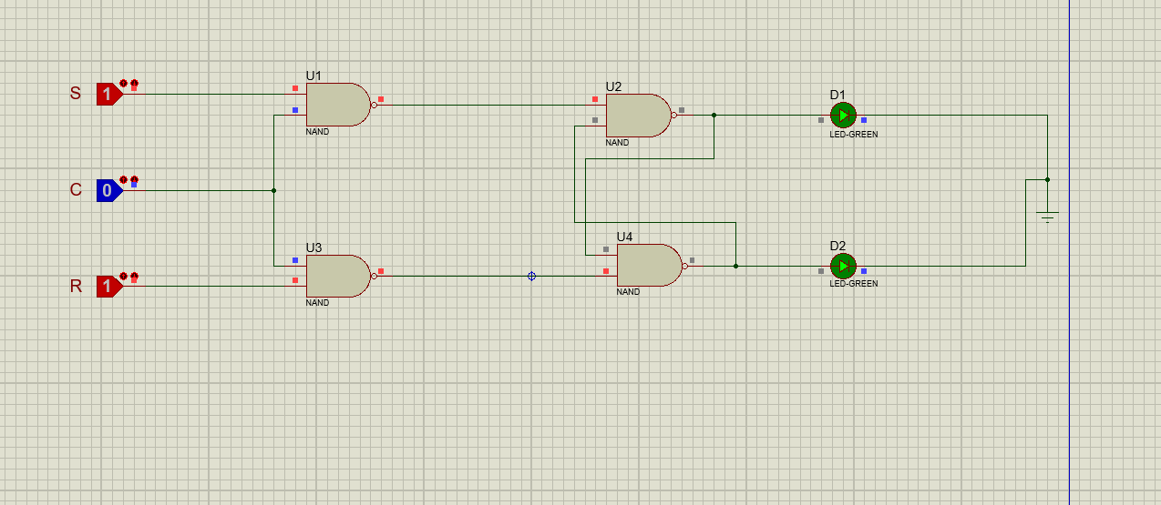

1. Construct the circuit on the breadboard and fill the following truth table according to the outputs your circuit gives.

|  |  |  |  |
| --- | --- | --- | --- |
| **C** | **S** | **R** | **Next State of Q** |
| **0** | **X** | **x** | X |
| **1** | **0** | **1** | 1 |
| **1** | **0** | **0** | 1 |
| **1** | **1** | **0** | 0 |
| **1** | **1** | **1** | unstable |

## Introduction to 555 Timer

The 8-pin 555 timer must be one of the most useful chips ever made and it is used in many projects. With just a few external components it can be used to build many circuits, not all of them involve timing.

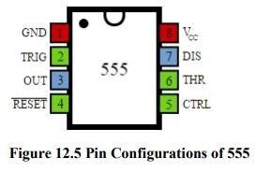

## Pin Description

**Trigger input:** when < 1/3 Vs ('active low') this makes the output high (+Vs). It monitors the discharging of the timing capacitor in an astable circuit. It has a high input impedance > 2M

.

**Threshold input:** when > 2/3 Vs ('active high') this makes the output low (0V)*. It monitors the charging of the timing capacitor in astable and monostable circuits. It has a high input impedance > 10M .

* providing the trigger input is > 1/3 Vs, otherwise the trigger input will override the threshold input and hold the output high (+Vs).

**Reset input:** when less than about 0.7V ('active low') this makes the output low (0V), overriding other inputs. When not required it should be connected to +Vs. It has an input impedance of about 10k

**Control input:** this can be used to adjust the threshold voltage which is set internally to be 2/3 Vs. Usually this function is not required and the control input is connected to 0V with a 0.01μF capacitor to eliminate electrical noise. It can be left unconnected if noise is not a problem.

The **discharge pin** is not an input, but it is listed here for convenience. It is connected to 0V when the timer output is low and is used to discharge the timing capacitor in astable and monostable circuits.

## 555 Astable

An astable circuit produces a 'square wave', this is a digital waveform with sharp transitions between low (0V) and high (+Vs). Note that the durations of the low and high states may be different. The circuit is called an astable because it is not stable in any state: the output is continually changing between 'low' and 'high’.

The time period (T) of the square wave is the time for one complete cycle, but it is usually better to consider frequency (f) which is the number of cycles per second

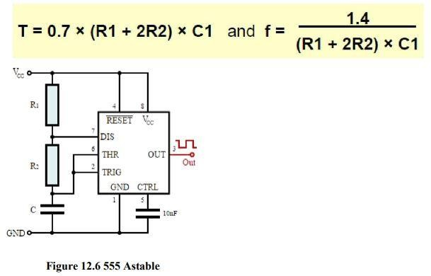

T = time period in seconds (s) f = frequency in hertz (Hz) R1 = resistance in ohms ( ) R2 = resistance in ohms ( ) C1 = capacitance in farads (F)

Choosing R1, R2 and C1

R1 and R2 should be in the range 1k to 1M. It is best to choose C1 first because capacitors are available in just a few values.

* **Choose C1** to suit the frequency range you require (use the table as a guide).
* **Choose R2** to give the frequency (f) you require. Assume that R1 is much smaller than R2 (so that Tm and Ts are almost equal), then you can use:
* **Choose R1** to be about a tenth of R2 (1k min.) unless you want the mark time Tm to be significantly longer than the space time Ts.
* If you wish to use a **variable resistor** it is best to make it R2.
* If R1 is variable it must have a fixed resistor of at least 1k in series (this is not required for R2 if it is variable)

